**Feedback Engagement Tool (FET) user guide**

This is what you will see upon opening the file

**The excel file has three tabs to help you take apart and keep track of all your feedback:**

1. **Feedback tracker** **tab** is there for you to log all the past feedback received and to review your feedback categorically before starting a new piece of assessment.
2. **Resources for improvement tab** presents links and resources you can use to help you improve skills mentioned in your feedback and to feedforward in future assessments.
3. **Skills info** **tab** contains definition of skills, this can be used as reference when taking apart and logging your feedback.

**Instructions for using the Feedback tracker tab**

# Logging your feedback

An example is provided in the first line of the spreadsheet. Use this to guide you for inputting your own feedback. You can delete it afterwards. If you require more in-depth instructions please see below.

Start with your most recent assessment and work backwards. For each assessment:

1. Type the relevant Year the assessment was in
2. Type the unit/module the assessment was in
3. Add in assessment title as you know it
4. Read through your feedback for that assessment and summarise at least TWO feedback points (one thing you did well and one thing to improve), adding more rows to cover more points if required

*To add in new rows:*

*Add in new rows by right clicking the cell highlighted in the picture, select “Insert”, then select “Entire row” and click OK.*

1. Indicate which point was something you "did well" and which was "need to improve" (this allows the summary table on the right to do it's magic) using the drop down options

*Select the next available cell, click on the arrow highlighted in* ***RED*** *to bring up drop down list.*

1. Now interpret which skills were relevant to each point of feedback using the drop down list

*You can scroll down the drop down list to see the full selection*

1. Add in any notes or reflections that you have about the assessment
2. Finally, consider if any action needs to be taken to address the feedback which will help you improve for future assessments. Look in the "Resources for improvement" tab for a wide range of learning resources.

# A chart with text on it AI-generated content may be incorrect.Reviewing your feedback

ck

Track where you need to improve

1. The table on the right is automatically updated to keep a tally of the number of times a skill is coupled with the feedback you logged

*Note: if this is not updated, please check you have selected the skills involved (column F) correctly.*

1. Use the table to help you decide your priorities
   1. If the number is high/shown as red on the “Need to improve” column (column K), the skill has been mentioned and identified for improvement in multiple feedback. You may wish to put more emphasis on improving that skill.
   2. Likewise, if a number is high on “Did well” (column L), you are doing a good job of demonstrating that skill in your assessments. Keep it up and check you have continued to do so in your next assessment!

## **Using the resources for improvement**

1. Click on **Resources for improvement tab**
2. Use the drop down arrows to select the skill you are looking for resources on. Simply click on the arrow and start typing the skill you wish to view resources for in the box highlighted, then click OK.

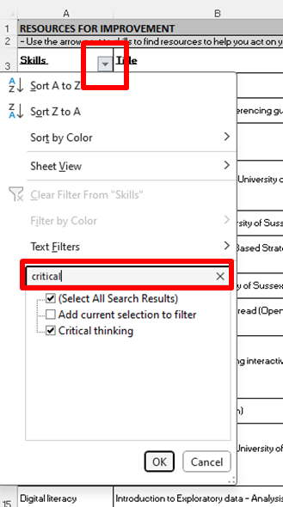

*You can filter by skills and by type of resources.*